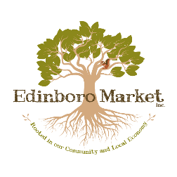

Artisan # ___________

**Edinboro Market, Inc. Artisan Application**

Please direct all questions to [EdinboroMarket@gmail.com](mailto:EdinboroMarket@gmail.com) or 814-266-2993

**Name(s)** _______________________________________________________________________________

**Name/Business Name** _____________________________________________________________________

**Mailing address (for checks)** ____________________________________________________

**Street address (if different than above)** ______________________________________________________

**City** __________________**State** ______________ **Zip** ____________

**Phone** ___________________________________

**Email** __________________________________________

**Facebook** _______________________________________________________

**Web page** ______________________________

**Please list the products you would like to sell at the market:**

_______________________________

________________________________________________________________________________________

________________________________________________________________________________________

**Edinboro Market, Inc. supports local artisans who use locally produced materials whenever possible. Where do the majority/main components of your product originate? If none of the components originate in this area in what way does the topic reflect our region’s agricultural heritage?**

________________________________________________________________________________________

________________________________________________________________________________________

________________________________________________________________________________________

________________________________________________________________________________________

________________________________________________________________________________________

________________________________________________________________________________________

**What else should we know about you, your products, and your business practices?**

________________________________________________________________________________________

________________________________________________________________________________________

________________________________________________________________________________________

________________________________________________________________________________________

________________________________________________________________________________________

________________________________________________________________________________________

**Agreement:** I have read and understand the Edinboro Market Artisan Guidelines. I agree to comply with the Edinboro Market Procedures and Guidelines. I affirm that all information in the application is complete and accurate. I have attached a W-9 for tax purposes. I will provide proof of $500,000 liability insurance required by Edinboro Market.

Signed: __________________________________________

Date: ___________________________________________

**Financial information:**

Checks should be made payable to: ______________________________

Tax ID# or SS# __________________________________________