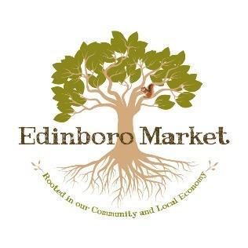

Producer # ___________

**Edinboro Market Producer Application**

Please direct all questions to [EdinboroMarket@gmail.com](mailto:EdinboroMarket@gmail.com) or 814-266-2993

Name(s) _______________________________________________________________________________

Farm/Business Name _____________________________________________________________________

Mailing address (for checks) _______________________________________________________________

Street address (if different than above) ______________________________________________________

City ___________________________________State ____________________ Zip ___________________

Phone __________________________________________________________

Email ___________________________________________________________

Facebook _______________________________________________________

Web page _______________________________________________________

**Please list the locally produced food/products you would like to sell at the Edinboro Market:**

(Includes produce, meat, dairy, eggs, honey/syrup, salsa, soap etc.)

________________________________________________________________________________________

________________________________________________________________________________________

________________________________________________________________________________________

**Basic details about your operation:**

Is your product certified organic? Yes ______ No ______ If yes, please attach certifications.

Do you seasonally pasture your meat/egg animals? Yes _____ No _____

Do you routinely use antibiotics on your livestock? Yes _____ No _____

Do you use any chemical sprays and/or synthetic chemicals of fertilizers? Yes _____ No _____

Do you use non-GMO seed? Yes _____ No _____

Do you use non-GMO feed? Yes _____ No _____

**Producer Information for market outreach:**

Please provide a short bio along with details about your operation and production practices including information about your product and production process(es). This information will be shared with market customers in order to help them to understand the benefits of knowing where their food comes from and how it is produced, e.g., it’s fresher, preserves genetic diversity, supports local families, builds community, etc.

**Agreement:**

I have read and understand the Edinboro Market Rules, Procedures and Guidelines and agree to comply with these. I have signed and attached a W-9 form for tax purposes. I affirm that all information in this application is correct and accurate. The products I bring to Edinboro Market are produced in accordance with all Pennsylvania Department of Agriculture and Erie County Department of Health regulations and I have attached all licenses, etc. to this agreement.

Signed: _____________________________________________________

Dated: _____________________________________________________

**#### We will need a Certificate of Liability Insurance (accordia form) to show you currently have liability insurance ($1M coverage) to cover any products you bring to the Edinboro Market, Inc. ####**

**Financial information:**

Checks should be made payable to: ________________________________________________________

Tax ID# or SS# _________________________________________________________________________